**Sample Short Answer Response**

**Question 1**

Analyse how Text 1 works to convey an idea about human nature.

**Text 1**

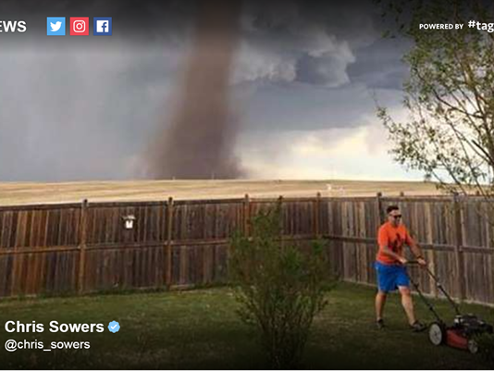

**Response 1**

Mowing the lawn is an activity that Australians can relate to because most inhabitants of our land ‘down under’ have their own patch of paradise that regularly needs clipping in order to keep nature under control. The use of composition and camera shot in Text 1 works to convey the idea that it is human nature to be consumed by our own lives, to the extent that we are oblivious to the dangers that surround us.

The man mowing the lawn in the image is positioned along the bottom of the right vertical intersection of the rule of thirds. This, together with the use of a long shot, works to emphasise his small, insignificant size, relative to the twister which is superimposed above him and dominates the upper position of the image. Moreover, this positioning highlights his carefree and relaxed body language as he mows the lawn, shoulders and arms relaxed, as well as his sunglasses symbolising being shielded from his surroundings, to convey dramatically the menacing and overpowering nature of the tornado, as it usurps the majority of the image, making the man look insignificant and powerless in its presence. This further conveys the idea that it is human nature to remain passive and to not take action when our dangerous surroundings continue to pervade our lives. It also suggests that some of us are not even aware that we are in danger as the man seems totally unaware that he is about to be thrust into a potentially life-threatening situation or, if he has noticed the cyclone, he is so determined to go about his own business and finish what he set out to do, that he is content to simply ignore it.

The positioning of the wooden fence, forming a rigid line from either side of the frame, abruptly divides the image, separating the menacing weather event from the presumably unaware man. This division by the fence serves as a symbol for being sheltered from the dangers that threaten us, yet not fully protected, as the tornado dominates the image and approaches the low-lying fence. The large scale of the twister, with its centre positioned in the middle of the image, emphasises its danger and its proximity to the man. The tonal contrast between the centre of the tornado, which extends as a dark, leading line towards the fence, and its outer parts which extend across the frame, convey how the man’s obliviousness will soon be disrupted by the tornado’s approach, targeted through the centre of his yard. This conveys the idea that it is human nature to be occupied by our own lives and unaware of the destruction around us which can have dangerous and inevitable consequences.

**Response 2**

Human nature is most tellingly revealed in the face of hardships, danger and threats. The resulting resilience of human nature, and the subsequent ignorance of its effects, is conveyed in Text 1 through its composition, setting and contrast.

In the photographic medium, Text 1’s construction of composition emphasises the vast, looming and overwhelming threat of the tornado. With the twister taking up the large majority of the picture, consuming the background in this long shot, it works to emphasise the scale of this natural phenomenon and create an image of the intimidating power of natural disaster further working towards a contrast between man and environment while highlighting the sheer impact of nature in the setting.

The setting of Text 1 exists in two contrasting forms with the dry and desolate distance in the background, seen through its elevated camera angle that conveys the harshness of the environment as opposed to the lush, groomed garden highlighting humanity’s innate nature to control the world around us. The setting is further constructed as ominous through the looming, layered clouds, emphasising the bravery and resilience of the man. The setting in the garden is contained and groomed constructing it as tameable – how humanity sees the environment despite the contradiction within the image.

Contrast underpins Text 1 and is seen through composition, which highlights the difference within the setting in order to convey the resilient but blissful ignorance of man in the face of nature. Contrast exists most prominently in scale through more technical conventions of camera angle and framing, reinforcing the ominously all-consuming scale of the tornado against the fragility of man which is further cemented with the focal point and central position of the tornado making it seem more powerful and more significant.

Despite the imbalance between human and nature – the idea of resilience within human nature is telling. Armed with casual shorts and shirt costume reminding the viewer of man’s casual, nonchalant, blissful nature, which rationally seems ignorantly stupid, simultaneously conveys a bravery and a carefree approach in the face of danger, which in turn speaks to human nature’s strength - in the world humanity has created for itself.